# ICE 4 – Mad Libs

## Phase 2 – Initial Screen

**Context:** When the JAR file initially starts up it displays “Mad Libs” as a welcome banner and it displays instructions for the user input (which in this case, it would be): “ Please enter an adjective: ”.

## Phase 3 – Input Screen

**Context:** Instructions appear to the user on new individual lines as the user enters input, this would be how the screen looks when all data is filled out

## Phase 4 – Output Screen

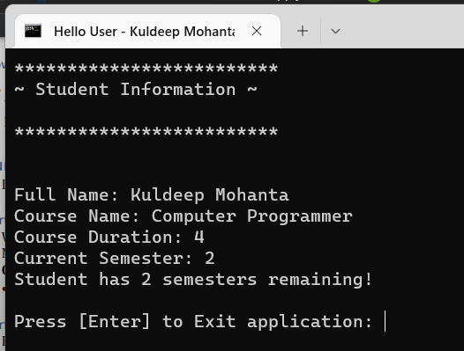



**Context:** After entering all information required during the “Student Registration” screen, the terminal clears and displays the inputted string values under the “Student Information” banner. Then after which, it shows an “Enter to exit Application” input line.

## Part 5 – Answer the Questions

**Question 1) In Java you must declare the variables before using them, what does it mean?**

When declaring variables in Java, it assigns a specific data type (i.e., integer, a string), reserve memory for it, as well as assign a name to the variable so that it can be referenced later in the program. It is important to note that assigning a name to the variable allows the program to follow the value of the variable. While recognizing the data type helps to determines the kind of value(s) that the variable can hold and the amount of memory that can be reserved for it.

**Question 2) What happens if you store the user’s name in a variable declared as an integer?**

­When attempting to store string data within an integer data type variable, it result in a compile error – which is what happens when the compiler finds problems within the code that it does not understand or something that does not follow the standards of the programming language. On that note, an integer variable can only store numerical values while the user’s name would be an inappropriate data type to try and store (string value).